Nanotechnology in camera development

idk , something something cam become small. Something about primitive cams nid a development room to create pics. Link to next paragraph.

Technology:

Thomas Wedgwood was the first person to create a photograph using chemistry. He used exposure to direct sunlight to capture the silhouettes of objects in contact with a silver nitrate treated surface. By going through the exposure process, the sunlit areas darkened while the areas in shadow did not. This process of his experiment relies on the photo-chemical[1] reaction of the silver nitrate solution, which was used to treat the surface before being exposed to sunlight.

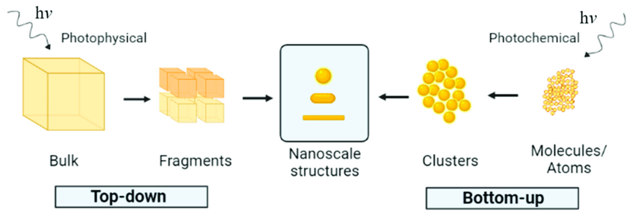

As shown in the picture above, photophysical uses the top-down approach to alter the molecular structure of the material. This is likely the process used during Thomas Wedgwood’s process of creating a photograph.

*“It is well known that under the influence of light such elements as sulphur and phosphorus gradually become transformed into their so-called "allotropic " modifications, ordinary phosphorus becoming red or amorphous and a strong solution of sulphur in carbon disulphide slowly depositing the insoluble modification when exposed to sunlight in a sealed tube [ A] . So also certain metallic salts, such as the crystalline chloride or iodide of silver, nickel sulphate and zinc selenate, experience a change in crystalline form under the influence of light.” [2]*

The exposure of silver nitrate to light causes the structure of the chemical to change, resulting in the darkening of the solution.

advantages:

This is a huge milestone for the history of photography, since there was no other way to capture images other than using a camera obscura and manually tracing the image manually. A camera obscura, literally translated to dark chamber from latin, is usually a dark room with a pinhole to allow light inside, forming an inverse image of the scene onto a surface (a wall).

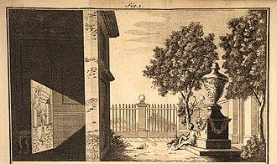

An illustration of explaining the principles of a camera obscura

This prolonged practice of copying images in a dark, poorly lit room as well as another possible practice of looking at the scene composition using the pinhole can lead to constant eye strain, and eventually lead to myopia. By using this method to produce images, the process may reduce the amount of eye strain from direct light exposure to the eyes, therefore prolonging a healthy vision of people developing images.

Disadvantages and challenges:

Though Thomas Wedgwood’s discovery helped lay the foundation to the future development of cameras, the images produced by this method are more accurately identified as photograms. Since the image only shows the silhouettes of objects, it may appear unrealistic or be hard to make out the shape of the objects (highly dependent on composition and personal preference, otherwise take this with a grain of salt). More importantly, Thomas Wedgwood was not able to create the images using a camera obscura as initially planned, the images created were not permanent in the first place. It wasn't until 7 years later after his discovery, that Joseph Nicéphore Niépce developed heliography to produce an image with a camera obscura.

(how do i link this oh god)

Im lazy to write at this point, so im just going to list down some points i intended to write:

* Prolonged usage of silver chemicals
  + Did a bunch of cross reference checks, some articles be saying its pretty dangerous, others be saying its fine as long as the concentration isnt too much (since we are exposed to small about of silver in our daily lives)
  + I guess its just safe to say, people in photo development industry back then and even now just need to be careful not to accidentally ingest whatever chemical they use to develop pictures. Even if they do its probably fine anyways.
* Consistency
  + Weather is pretty unpredictable, so i imagine it must be difficult to have optimal exposure to light throughout the entire process to produce a clean and even result

Conclusion:

These people be pretty amazing and very creative honestly. I have no idea how they even got the idea of “recording images”. Its so far fetched it still blows my mind. Also there’s a video i saw on reddit about using a high frame rate camera to record how light hits and projects images to our eyes. Pretty interesting, i dont really remember the details of it, but it went something along the lines of light being really fast and the projection of light images.

[The Chemistry of Photography, by Raphael Melodola](https://books.googleusercontent.com/books/content?req=AKW5QadPlQUT9vJ4TB2ibyhRDRkYvUTB0hQefYcvDSaV4Z2t7Rn05432WFCWFnEnpoBbrMRpL9QqNiI-EljsAo6flNFQt-_XI325aHaCE8Br_-zmvmlKxHYtxpFx2SqqMEoI8A_T6svcpMFSoVI7hN8TJgHbavs6ukuQpRcjW_QznoV03df6SM0SDNxwPauLUs8LNMl7ajSWqnOzWVv7wSpeeAc40m7v-KjDhLfBlCg4ozV51kjmP5YxxOSrE2ve7oiVBChxGaJbTFueJPtEoqgz5ZryEBDVfw)

[Nearsightedness - Symptoms and causes - Mayo Clinic](https://www.mayoclinic.org/diseases-conditions/nearsightedness/symptoms-causes/syc-20375556#:~:text=Nearsightedness%20is%20a%20common%20vision,rays%20to%20bend%20or%20refract.)

[Is reading in the dark bad for your eyesight? (bbc.com)](https://www.bbc.com/future/article/20121001-should-you-read-in-the-dark)

[Nicéphore Niépce - Wikipedia](https://en.wikipedia.org/wiki/Nic%C3%A9phore_Ni%C3%A9pce)

[Silver Toxicity - StatPearls - NCBI Bookshelf (nih.gov)](https://www.ncbi.nlm.nih.gov/books/NBK604211/)

[Microsoft Word - 1672.doc (nj.gov)](https://nj.gov/health/eoh/rtkweb/documents/fs/1672.pdf)

[How Much Silver is in Photographic Films, Papers, and Chemicals | 100ASA](https://100asa.com/blog/how-much-silver-is-in-photographicfilms-papers-and)

Most of the reference be from wikipedia, but i do cross reference with different pages (especially the historical figures) to get as much details as possible  
Image reference:

<https://www.researchgate.net/publication/353578291/figure/fig1/AS:1051265559699460@1627652649803/Illustration-of-the-photochemical-formation-of-nanoparticles.png>

[Camera obscura - Wikipedia](https://en.wikipedia.org/wiki/Camera_obscura)

THIS IS OLD REPORT, IGNORE THIS

**Nanotechnology in cameras**

#### Topic : nanotech in consumer electronics and development

Sidenote: it was meant to be an essay about nanotech used in cameras, but I got distracted by the camera rabbit hole. So in reality, this is a summary about the history of cameras O|<

Hopefully, i’ll remember to mark out the bits to focus on for marking

## Introduction:

It is no surprise that cameras of the modern age have become the way it is from a long line of development. What was once an enormous apparatus has now been reduced to a mere smartphone component smaller than a button. It is, frankly, unimaginable to picture how different our daily lives would be without the introduction and rapid development of cameras into our lives.

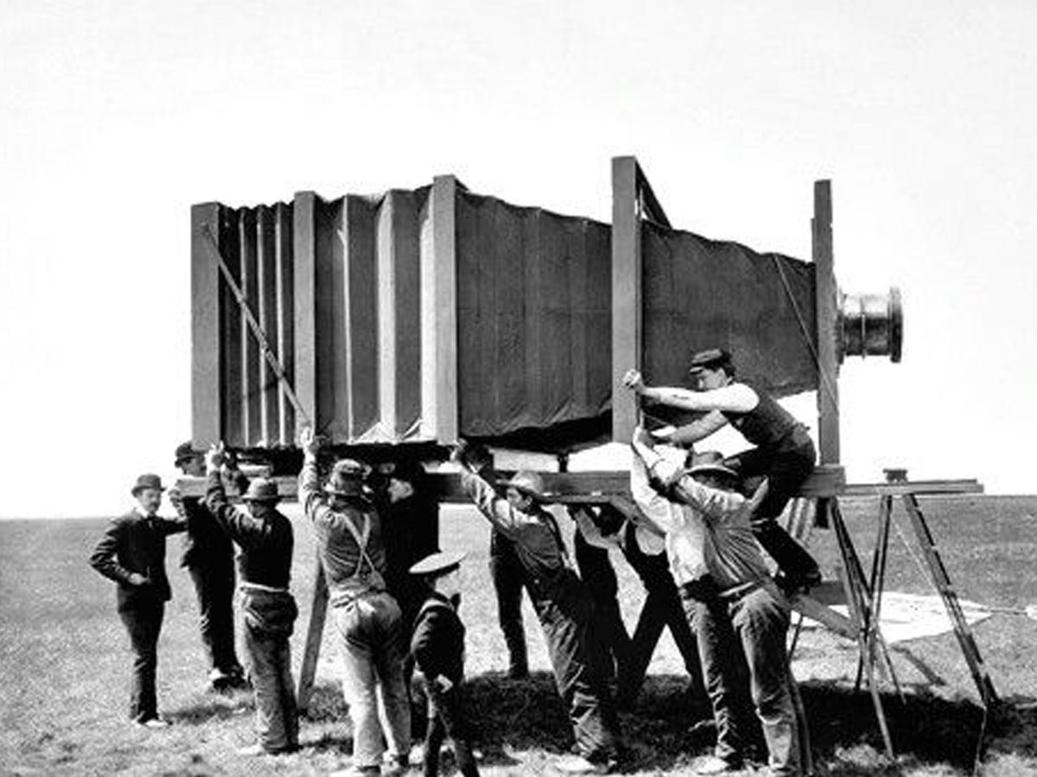

Second camera in the world to take the first ever picture, 1816

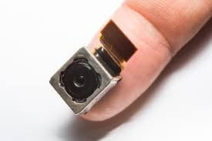

Current day smartphone camera

This article will be a brief exploration into the nanotechnologies used to develop cameras to the way it is today.

(Apparently, photography using cameras is the act of creating images by **recording light**… Who even found out this was possible w h a t?)

## History of science behind photography

Timeline of camera development milestones:

Pre-17th century -> usage of camera obscura

1736 - 1819 -> first images created chemically

1826 -> first permanent photograph of a camera image created, founding of heliography

1839 -> introduction of daguerreotype camera for commercial manufacture

1841 -> founding of calotype process (eventually lead to improvement in printing)

1841 -> creation of camera with half-sized plate, by charles chevalier

1841 -> creation of appareil gaudin camera, by marc antoine gaudiin

Even before the first camera was created, photography initially came from usage of a natural light phenomenon known as camera obscura, or pinhole image.

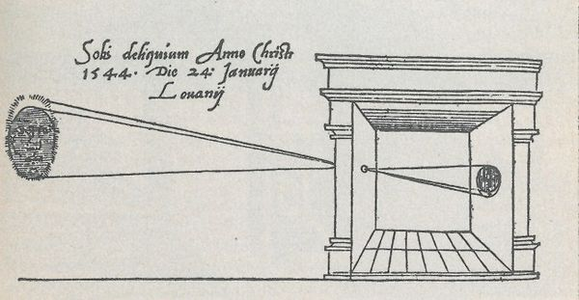

First published picture of a camera obscura, from 1545 book “De Radio Astronomica et Geometrica”

The phenomenon projects an inverted image of a scene from the one side of a surface through a small hole onto another surface opposite the hole. Since there was no technology that existed to preserve the images produced, people had to manually trace the images in order to obtain a physical picture to keep.

Following the use of pinhole images, the creation of images was then made chemically. (i swear to god, the amount of substances people were exposed to back then is highly questionable. But hey, life finds a way.) Light sensitive substances such as silver salts (silver halide) and silver chloride were experimented on. Thomas Wedgwood eventually became the first person to create images by chemical means. He had initially attempted to capture real world scenes with a camera obscura but failed. He did, however, succeed in creating images by capturing silhouette images of objects in contact with silver nitrate coated surfaces such as leather and paper.

In 1841, english scientist William Henry Fox Talbot developed a process called calotypes, which allows photographs to the created on paper

## advantages/ enhanced features:

## Challenges:

## Conclusion:

## References:

[Thomas Wedgwood photography achievement](https://en.wikipedia.org/wiki/Thomas_Wedgwood_(photographer)#A_pioneer_of_photography)

Memes (because my priorities are skewed):

|  |  |
| --- | --- |
| Lbn Al-Haytham “Al Haitham” then | Al Haitham now |

1. was initially “photochemical” instead of “photo-chemical”, but i think it is more accurate to say it was a chemical “photosynthesis” reaction instead of the actual definition of a photochemical reaction

  
2. Pg 33 of “The Chemistry of Photography”, by Raphael Melodola